Blog Post
Too many keywords in an ad group, how do I segment out the keywords into different ad groups without having to rebuild my campaign which will take hours?
I was working on a client’s campaign recently and the first think I notice, which happens a lot, is that the client had a pretty wide variety of keywords within one adgroup leading to a lack of focus and tough to create highly relevant ads for the keywords. We are aware that ad groups are essential component of pay per click marketing and creating effective ad groups will help you drive more traffic at much lower cost, while increasing the number of conversions on your site.
So that brings us to the question: how to create ad groups that really work?
Basically, in creating an Ad Group, you want to ensure that you're offering integration and consistency:
- Integration - Create a system where the keyword, ad text and landing pages are tightly integrated with one another.
- Consistency - This integration should lead to messaging consistency.
The two main reasons these things are so important are listed below:
- Lower Costs – By creating well-aligned ad groups, Google will reward you with a better quality score which means that you'll be paying less money for the same clicks.
- More Conversions - If I search for "personal injury lawyer" and your advertisement talks about “personal injury lawyer” and then your landing page is a website providing personal injury lawyer services I am much more likely to convert than if your ad text or landing page have nothing to do with one another or aren't integrated with your keywords.
So how do you achieve this close integration in your PPC campaigns? Consider using iSpionage keyword grouping solution.
iSpionage provides you with a keyword grouping tool that allows you to populate or build your keyword lists, and group the keywords according to a theme followed by creating the ad text and launching the campaigns.
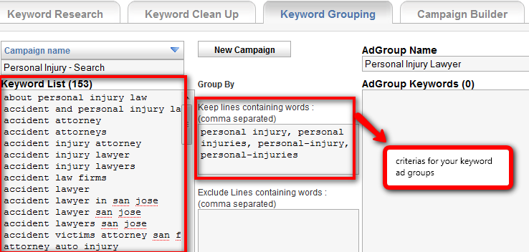

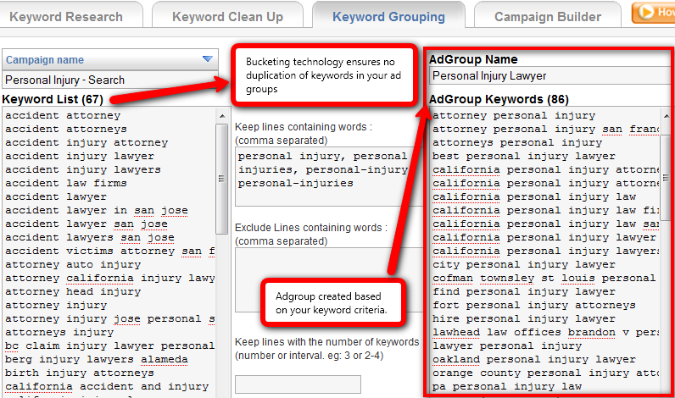

You can see from the above screen shots that I have segment out the keywords according to my criteria and with the click of a button, I have create a highly target ad group. iSpionage’s “keyword bucketing technology” also ensures that we don’t end up with duplicate keywords in our ad groups. You can create as many ad groups as your keyword list permits and the next step is simply launching your campaign which iSpionage will take you through the steps of doing it by clicking on the campaign builder tab. The BEST thing about this tool is the amount of time you will save when you use it. If you had to do all this using the Google adwords interface it will probably take several hours. iSpionage keyword and campaign builder tool will make it a breeze for you!

Check out the video below and try it now for Free!

